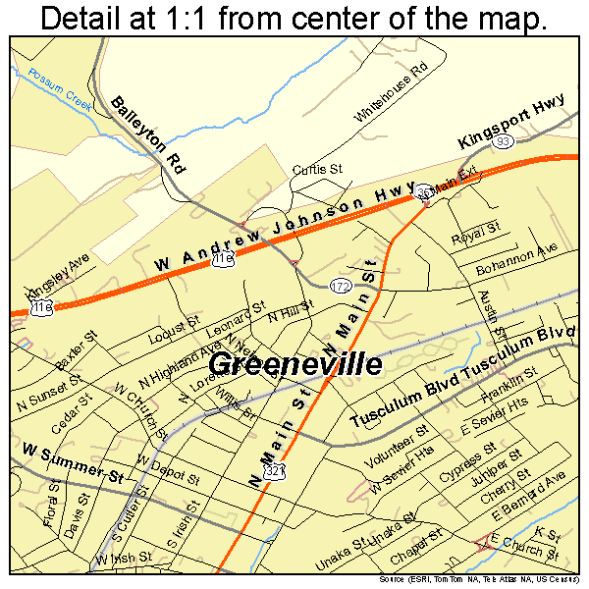

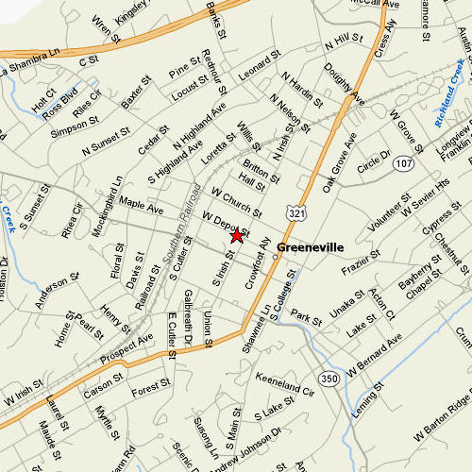



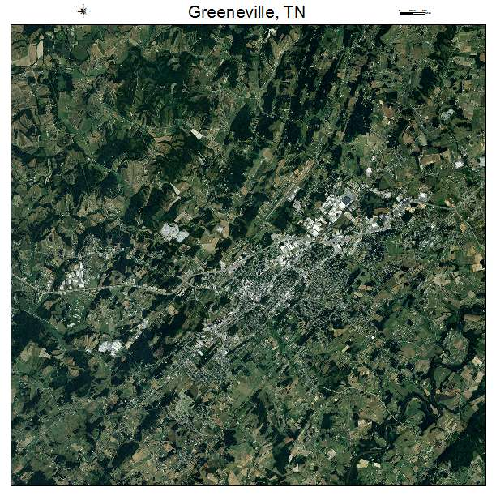

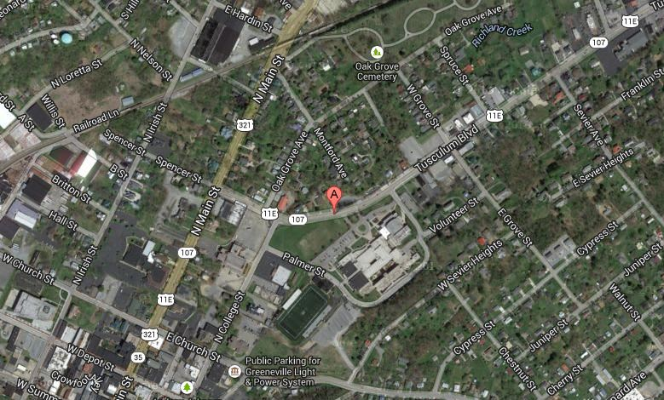

https://www.bing.com/images/search?view=detailV2&ccid=AZhiBnf3&id=0AED43534FB4F2D0E69142A50F2842E1098BE4FB&thid=OIP.AZhiBnf3GVmUHWPB4b9oKwEsC1&q=aerial+photo+of+greeneville%2c+tn&simid=608040832635047130&selectedindex=13&mode=overlay&first=1